New Website Section | Current New Website Content | Suggestive Content  21-09-2026 | Suggestive Content  22-09-2026
M2 Attach: linking and sharing | Milestone 2 enables a Health Information Provider (HIP) to create digital health records and to generate and link care contexts with a patient's ABHA Address. It also enables the HIP to facilitate record discovery through a Personal Health Record (PHR) application, and to securely share encrypted health information across the ABDM ecosystem. | Milestone 2 enables a Health Information Provider (HIP) to create digital health records and link them with a patient's ABHA Address, facilitate record discovery through a Personal Health Record (PHR) application, and securely share encrypted health information across the ABDM ecosystem. | Please add the Suggestive Content from 21-09-2026
Error Codes |  | M2 Error Codes are not available  Link for M2 error codes:  Annexure 1
In short | Milestone 2 enables a Healthcare Facility, acting as a Health Information Provider (HIP), to link a patient's health records with the patient's ABHA Address and make such records available within the ABDM ecosystem. The linkage of records may be carried out through either HIP-Initiated Linking or User-Initiated Linking.  - HIP-Initiated Linking. In this workflow, an ABDM-enabled Healthcare Facility links the patient's health records and care contexts with the patient's ABHA Address during the course of care, following successful patient authentication. The linked records are subsequently made available through the patient's PHR application.  - User-Initiated Linking. In this workflow, a patient initiates the linkage of previously generated health records through a PHR application. The HIP validates the patient details, identifies the corresponding records, and links the associated care contexts with the patient's ABHA Address upon successful verification.  - Data Transfer. Health information is structured in accordance with the HL7 FHIR R4 standard. The FHIR bundle is encrypted and securely exchanged through the ABDM ecosystem.  Capabilities under M2 | In short  Health Information Provider (HIP) links a patient's health records with the patient's ABHA Address and makes such records available within the ABDM ecosystem. | [The linkage of records may be carried out through either HIP-Initiated Linking or User-Initiated Linking.  HIP-Initiated Linking. In this workflow, an ABDM-enabled Healthcare Facility links the patient's health records and care contexts with the patient's ABHA Address during the course of care, following successful patient authentication. The linked records are subsequently made available through the patient's PHR application.  User-Initiated Linking. In this workflow, a patient initiates the linkage of previously generated health records through a PHR application. The HIP validates the patient details, identifies the corresponding records, and links the associated care contexts with the patient's ABHA Address upon successful verification.  Data Transfer. Health information is structured in accordance with the HL7 FHIR R4 standard. The FHIR bundle is encrypted and securely exchanged through the ABDM ecosystem.] - Remove this part from In Short
What M2 gives you | Capabilities under M2 | M2 Functionalities:  Care Context: A Care Context represents a patient’s visit to a healthcare facility and contains the health records generated during that visit. The healthcare facility links the Care Context with the patient’s ABHA Address.  The records may be linked through either HIP-Initiated Linking or User-Initiated Linking.  HIP-Initiated Linking: In this workflow, an ABDM-enabled healthcare facility generates a link token to authenticate the patient and links the care contexts with the patient's ABHA Address. The linked care contexts are subsequently made available in the patient's PHR application.  User-Initiated Linking: This flow allows a patient to find and link health records created earlier without an ABHA Address. The records are stored in the HMIS using the patient’s registered details. When the patient selects the fetch option in the PHR application, the healthcare facility matches the respective demographic details and shows the available records for linking with the patient’s ABHA Address.  Data Transfer: In this flow, each health record is converted into the prescribed FHIR format, packaged as a FHIR bundle, encrypted, and securely transmitted through the ABDM ecosystem. | Please add the Suggestive Content from 21-09-2026
Prerequisites | Prior to implementation of Milestone 2, the following requirements shall be fulfilled:  - The Healthcare Facility shall have a valid Health Facility Registry (HFR) ID, and the integrating software shall be registered and mapped to the facility as a Health Information Provider (HIP).  - The system shall support capture and verification of the patient's ABHA Address through the applicable ABDM authentication mechanism.  - The system shall generate and maintain digital health records for linking with the patient's ABHA Address.  - Health information shall be packaged in HL7 FHIR R4 format and conform to the applicable ABDM FHIR profiles published by NRCeS at nrces.in. | Prerequisites  Before implementing Milestone 2 (M2), ensure that the following prerequisites are fulfilled:  - The healthcare facility must be registered in the Health Facility Registry (HFR) and have a valid HFR ID (facility ID).  - The HIP ID (Facility ID) must be linked to the corresponding Client ID to receive callbacks through the NHPR Portal or M4 APIs using software linkage.  - A valid callback URL must be configured for the Client ID using the Update Bridge API. | Please add the Suggestive Content from 21-09-2026
Record types you can link |  | 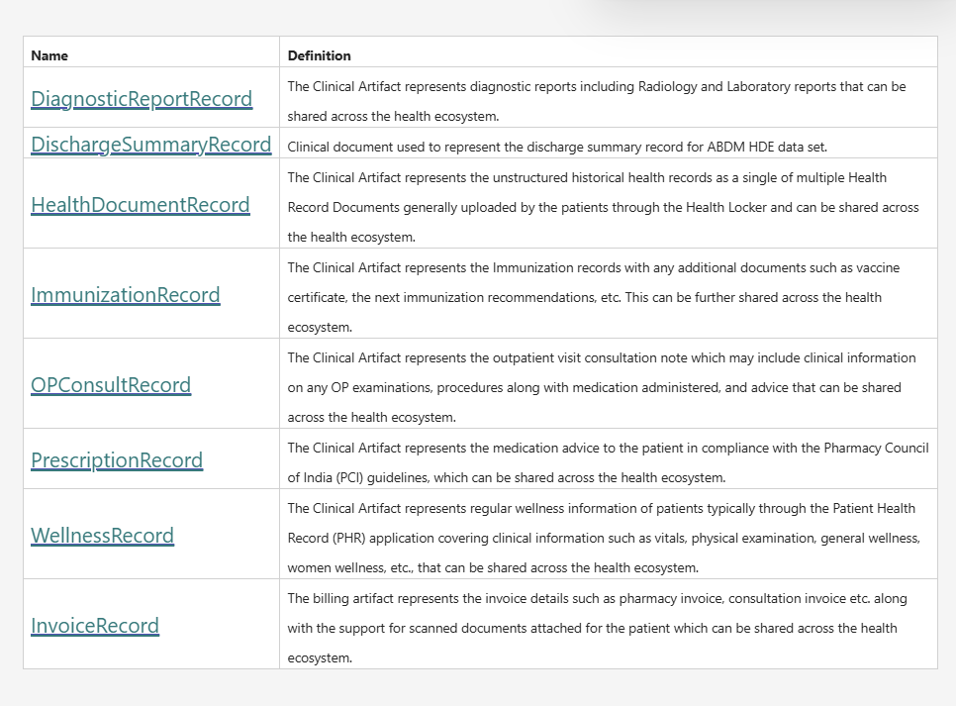 | FHIR-Based Health Records  In the ABDM ecosystem, every health record is created and shared in a standardized format called FHIR (Fast Healthcare Interoperability Resources) to enable secure and interoperable exchange of health information.  FHIR is a globally recognized standard for structuring and exchanging digital health records.  FHIR Implementation Guide (ABDM):  https://nrces.in/ndhm/fhir/r4/index.html  Health Information Types  ABDM has defined 08 Health Information (HI) Types, comprising 07 Clinical and 01 Billing artefact.  Note: Each applicable Health Information Type is represented as a FHIR Document Bundle in accordance with ABDM standards.
Care Contexts |  |  | To be removed
Workflow Overview | This section presents the principal M2 workflows through separate sequence diagrams to provide an overview of the interactions among the participating systems before the detailed API specifications are described.  For the diagrams, "Your system" refers to the HMIS, LMIS, EMR or other ABDM-compliant software used by the health facility to perform HIP functions. "HIE-CM" refers to the Health Information Exchange and Consent Manager that facilitates consent management and the secure exchange of health information within the ABDM ecosystem. | Workflow Overview  This section explains the key Milestone 2 (M2) workflows using sequence diagrams. These diagrams provide a high-level view of how different systems interact before the detailed API specifications are discussed.  For the diagrams, "Your system" refers to the HMIS, LMIS, EMR or other ABDM-compliant software used by the health facility to perform HIP functions. "HIE-CM" refers to the Health Information Exchange and Consent Manager that facilitates consent management and the secure exchange of health information within the ABDM ecosystem - To be removed | [For the diagrams, "Your system" refers to the HMIS, LMIS, EMR or other ABDM-compliant software used by the health facility to perform HIP functions. "HIE-CM" refers to the Health Information Exchange and Consent Manager that facilitates consent management and the secure exchange of health information within the ABDM ecosystem.] – To be removed
Journey 1: HIP initiated linking | Flowchart | The HIP generates a linking token using the patient's ABHA address and demographic details for authentication. After successful verification, a linking token valid for 6 months is created, and the patient's care context is linked to the ABHA Address.  NOTE: Flow chart not completely visible, UI should be proper.  All steps of flow should be written, currently only 6 and 7 is written. Kindly write all the steps as per the Flow chart provided in this document.  Refer Annexure 2  If you hold no valid link token for the patient, generate a new one with the patient's ABHA address and demographic details before you link. – to be removed | Please add the Suggestive Content from 21-09-2026
Journey 2: User Initiated Linking | Flowchart | ABDM enables users to discover their health records from healthcare facilities they have visited through a PHR application. The discovery request is sent by the HIE-CM to the respective HRP/HIP, which searches for and returns the user's available care contexts.  If matching records are found, all relevant care contexts are shared with the user. The user can then select and link these care contexts to their ABHA Address.  All steps of flow should be written, currently only some steps are written. Kindly write all the steps as per the Flow chart provided in this document  Refer Annexure 3 | Please add the Suggestive Content from 21-09-2026
Journey 3: Health information request and transfer | Flowchart | Journey 3: Data Transfer Flow  The HIP sends structured and unstructured health information types in accordance with the NRCES FHIR standards. The FHIR bundle is encrypted and securely exchanged through the ABDM ecosystem  NOTE: Flow chart not completely visible, UI should be proper.  All steps of flow should be written, currently only some steps are written. Kindly write all the steps as per the Flow chart provided in this document  Refer Annexure 4  The HIU supplies the data push URL and its key material in the request. Encryption uses ECDH, Elliptic Curve Diffie Hellman, over Curve25519. Call order: - to be removed | Please add the Suggestive Content from 21-09-2026

Annexure 1:
M2 Error Codes:
Content: During ABDM integration, systems may encounter issues across discovery, linking, consent, encryption, and data exchange workflows. This section outlines common errors, their causes, and recommended resolutions to help ensure smooth implementation.
Code | Error
ABDM-1000 | Unable to connect the database
ABDM-1001 | No data found
ABDM-1004 | SMS Gateway is unavailable
ABDM-1006 | Bad Request, invalid request Body
ABDM-1007 | Connection failed due to timeout
ABDM-1008 | SMS service currently disabled
ABDM-1010 | Validation failed
ABDM-1011 | Gateway database unavailable
ABDM-1012 | No records found against the ABHA Address
ABDM-1013 | Invalid ABHA Number
ABDM-1015 | Invalid Response
ABDM-1016 | Invalid TimeStamp
ABDM-1017 | Invalid TransactionId
ABDM-1018 | Share Profile database unavailable
ABDM-1019 | Dependent Service Unavailable
ABDM-1020 | Unknown database
ABDM-1022 | Too many requests
ABDM-1023 | Invalid User
ABDM-1024 | Dependent service unavailable
ABDM-1025 | Invalid ServiceId
ABDM-1026 | Invalid Link Token
ABDM-1027 | You are blocked. Please try again after 24 hours.
ABDM-1028 | HIP is unavailable
ABDM-1029 | Redis server is unavailable
ABDM-1030 | Invalid request ID
ABDM-1031 | Invalid request
ABDM-1032 | Invalid header
ABDM-1033 | HIU is unavailable
ABDM-1034 | Notification service unavailable
ABDM-1035 | Invalid HIP ID
ABDM-1036 | Data does not matched
ABDM-1037 | Counter and Care context count mismatch
ABDM-1038 | ABHA address and Link token mismatch
ABDM-1040 | Invalid HIU ID
ABDM-1041 | Invalid Acknowledgement
ABDM-1042 | Provider Mandatory
ABDM-1043 | ABHA Address does not match with KYC details.
ABDM-1044 | Broadcast Failed
ABDM-1045 | Database Access is restricted
ABDM-1046 | Invalid Purpose
ABDM-1047 | Purpose does not exist
ABDM-1048 | Timeout
ABDM-1049 | Invalid Profile Share Intent Keys
ABDM-1050 | Invalid Profile Share Metadata Keys
ABDM-1051 | Invalid ABHA Number or ABHA Address
ABDM-1052 | Invalid TransactionId or response's requestId
ABDM-1401 | HIP is not available
ABDM-1061 | Consent artefact expired
ABDM-1062 | Consent Not granted
ABDM-1063 | Date Range given is invalid
ABDM-1064 | request with this request id already exists
ABDM-1017 | Invalid TransactionId
ABDM-1109 | ABHA DB service unavailable
ABDM-1108 | Notification DB service unavailable
ABDM-1034 | Notification service unavailable
ABDM-1029 | Redis server is unavailable
ABDM-1201 | IDP Gateway is unavailable
ABDM-9999 | Unknown exception
ABDM-1006 | Invalid combinations of scopes
ABDM-1006 | Bad Request, invalid request Body
ABDM-1056 | This care contexts has been already linked
ABDM-1055 | Invalid HIP Id or PHR Id
ABDM-1056 | Invalid Link Reference Number
ABDM-1057 | Invalid Care Contexts
ABDM-1059 | Invalid Care Contexts count
ABDM-1060 | Invalid Patient Reference Number
ABDM-1061 | Invalid Patient Display
ABDM-1062 | ABHA number mismatch with Link token
ABDM-1063 | HIP Id mismatch with Link token
ABDM-1064 | Request body was missing
ABDM-1065 | Invalid X Auth token
ABDM-1066 | Invalid JWT token
ABDM-1067 | Request body not required
ABDM-1170 | Invalid ABHA address
ABDM-1084 | ABHA address mismatch with X Auth token
ABDM-1085 | ABHA number mismatch with X Auth token
ABDM-1086 | Patient profile mismatch with X Auth token
ABDM-1087 | Duplicate patient share request
ABDM-1090 | Duplicate HIP link request
ABDM-1091 | Duplicate Get links request
ABDM-1092 | Duplicate Link token request
ABDM-1093 | Duplicate Bridge request
ABDM-1094 | Duplicate bridge patch request
ABDM-1095 | Duplicate Bridge service request
ABDM-1102 | Profile information cannot be null
ABDM-1103 | Duplicate Discovery request
ABDM-1104 | Duplicate Init request
ABDM-1105 | Duplicate Confirm request
ABDM-1106 | Duplicate On discovery request
ABDM-1107 | Duplicate On init request
ABDM-1108 | Duplicate On confirm request
ABDM-1109 | Invalid On discovery response
ABDM-1110 | Invalid On init response
ABDM-1111 | Invalid On confirm response
ABDM-1112 | Invalid or already expired consent artefact id
ABDM-1113 | Duplicate health information provider data flow response
ABDM-1149 | Intent type is not supported at HIP end
ABDM-1150 | Bridge API version cannot be null
- ABDM-1401 | HIP is not available
ABDM-1402 | Acknowledgement is not received from HIP
ABDM-9999 | HIP is unable to generate a token at this time. Please try again later.
ABDM-9999 | HIP is unable to process at this time. Please try again later.
ABDM-1030 | Request id not found
ABDM-2500 | No mapping found for
ABDM-2401 | The X Auth token is invalid.
ABDM-2402 | Invalid Timestamp
ABDM-2404 | Invalid Request Id
ABDM-2429 | Too many requests found
ABDM-2501 | Payment status should be : SUCCESS,CANCELED,PENDING,FAIL,REFUND_INITIATED,REFUND_SUCCESS
ABDM-2500 | Authorization header is missing
ABDM-2403 | Invalid X-CM-ID
ABDM-1086 | Patient profile mismatch with X Auth token
ABDM-2406 | Invalid API sequence flow, please follow logical flow
ABDM-2406 | The status is invalid. Please follow the logical status flow or transition.
ABDM-9999 | User not found
ABDM-1024 | Dependent service unavailable
ABDM-9999 | Cannot process the request at the moment, please try later.
ABDM-9001 | No open order against ABHA. Please ensure a minimum of one open order
ABDM-9002 | No registration found at <<hospital name>>. Contact counter support
ABDM-9003 | Hospital services temporarily unavailable. Please try again after some time.
ABDM-9004 | Services disrupted, please try again.
ABDM-9005 | Bank server not responding. Please try again later
ABDM-9006 | Service details mismatch. Please ensure original service ID from HMIS
ABDM-9007 | The Scan and Pay functionality is not enabled at this facility. Kindly contact the hospital administration.
ABDM-1006 | Invalid count, must be 2 digit and ranges between 1 to 20
ABDM-1407 | The ABHA Number associated with this ABHA Address is currently deactivated. Please reactivate it.
ABDM-1006 | Invalid HIType, it must be in Prescription,DiagnosticReport,OPConsultation,DischargeSummary,ImmunizationRecord,HealthDocumentRecord,WellnessRecord,Invoice

Annexure 2:
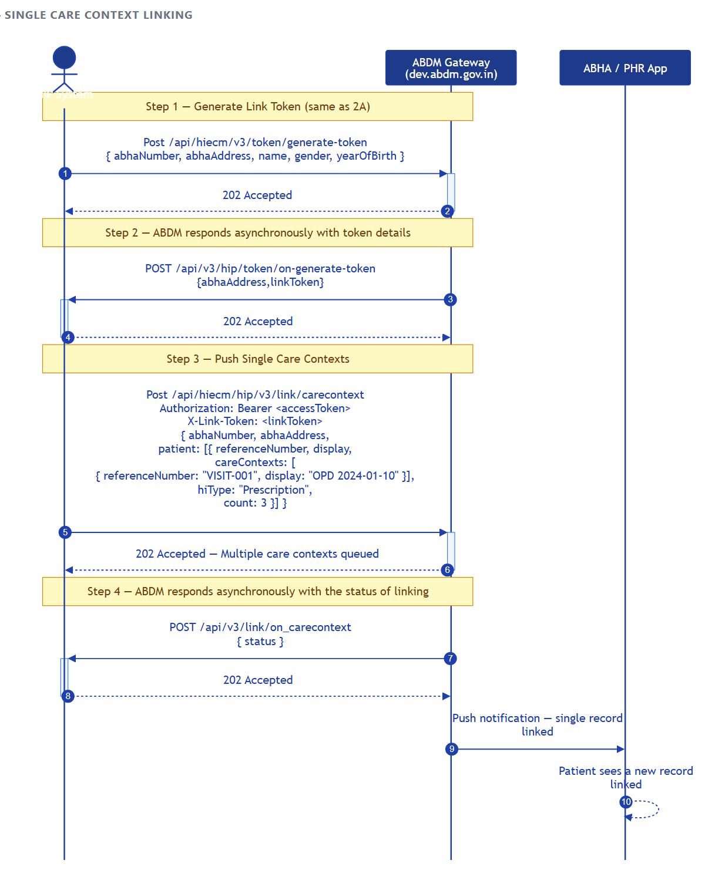

Annexure 3:

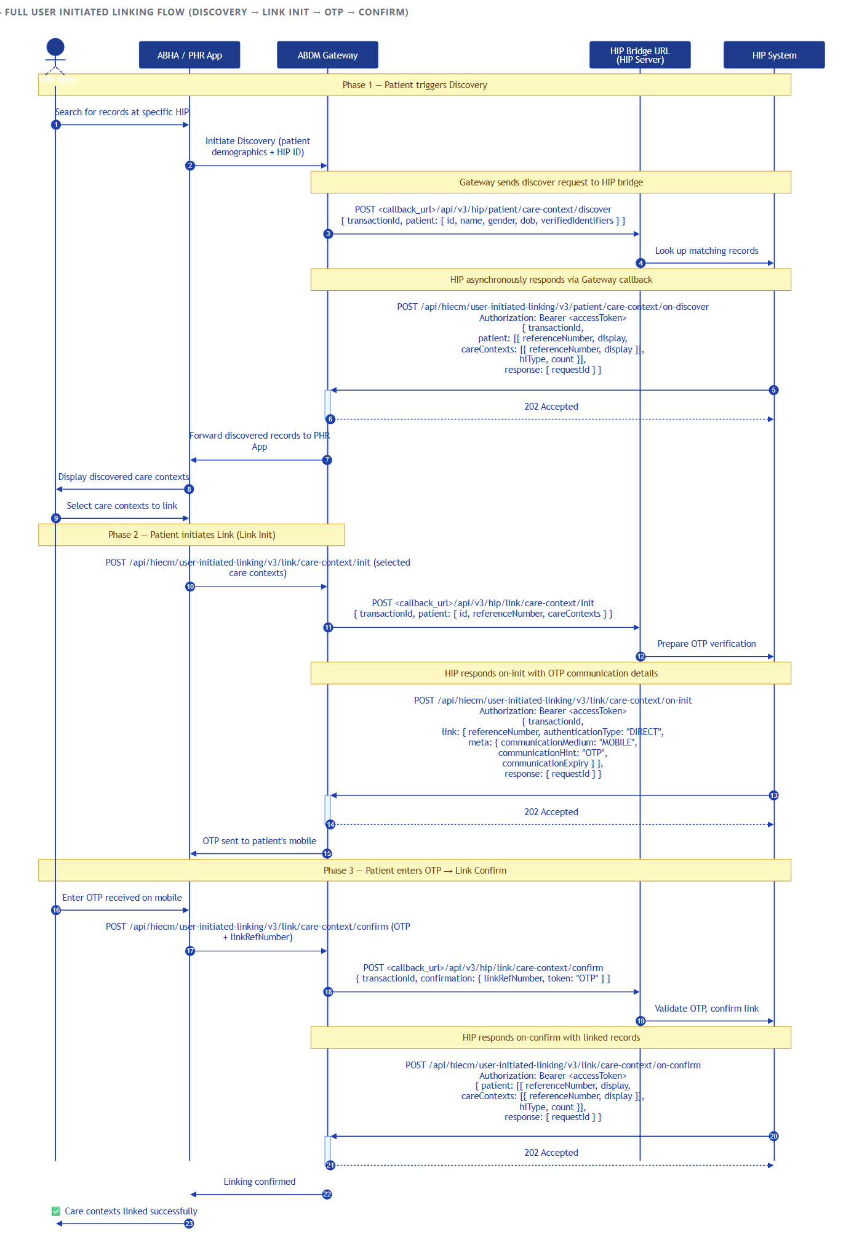

Annexure 4:

